[Egyptian Journal of Basic and Applied Sciences 5 (2018) 87–99](https://doi.org/10.1016/j.ejbas.2017.11.002)



Contents lists available at [ScienceDirect](http://www.sciencedirect.com/science/journal/2314808X)

Egyptian Journal of Basic and Applied Sciences

journal homepage: [www.elsevier.com/locate/ejbas](http://www.elsevier.com/locate/ejbas)

[](http://crossmark.crossref.org/dialog/?doi=10.1016/j.ejbas.2017.11.002&domain=pdf)Synthesis, characterization and anticancer activity of vincristine loaded folic acid-chitosan conjugated nanoparticles on NCI-H460 non-small cell lung cancer cell line

Naresh Kumar a, Raj Kumar Salar a,⇑, Minakshi Prasad b, Koushlesh Ranjan c

a *Department of Biotechnology, Chaudhary Devi Lal University, Sirsa 125055, Haryana, India*

b *Department of Animal Biotechnology, Lala Lajpat Rai University of Veterinary & Animal Sciences, Hisar 125001, Haryana, India*

c *Department of Veterinary Physiology and Biochemistry, Sardar Vallabhbhai Patel University of Agriculture, Meerut, 250110, Uttar Pradesh, India*

a r t i c l e i n f o

*Article history:*

Received 14 August 2017

Received in revised form 31 October 2017 Accepted 15 November 2017

Available online 26 November 2017

*Keywords:* Cancer Chitosan Vincristine

a b s t r a c t

Vincristine is used to treat different type of cancers. But unwanted side effects limit their applications in medicine. To overcome these side effects by targeted drug delivery approach, we synthesized vincristine loaded folic acid-chitosan conjugated nanoparticles by ionic gelation method. The nanoparticles were characterized using Dynamic Light Scattering (DLS), Fourier Transform Infrared Spectroscopy (FTIR), Scanning Electron Microscopy (SEM) and Transmission Electron Microscopy. DLS confirmed small sized nanoparticles (<200 nm) while FTIR confirmed different functional groups associated with synthesized nanoparticles. SEM showed spherical shaped nanoparticles with smooth surface, whereas, TEM con- firmed loading of vincristine in folic acid-chitosan conjugated nanoparticles. Anticancer activity of vin- cristine loaded folic acid-chitosan conjugated nanoparticles was checked by MTT assay on NCI-H460 cells followed by reactive oxygen species level, mitochondrial transmembrane potential and apoptotic morphological changes, which confirmed the cytotoxicity of nanoparticles. Erythrocyte aggregation assay confirmed non-toxicity of nanoparticles. Hence, these nanoparticles can be used to treat NCI-H460 cells.

© 2017 Mansoura University. Production and hosting by Elsevier B.V. This is an open access article under

the CC BY-NC-ND license (<http://creativecommons.org/licenses/by-nc-nd/4.0/>).

1. Introduction

Non-small cell lung cancer (NSCLC) is major type of lung cancer that bears almost 85% of major lung cancer types. Only 17.3% of the people who develop NSCLC survive for 5 years. NSCLC is an aggres- sive neoplasm, responsible for more lung cancer related deaths every year in the United States than colon, breast, pancreas, and prostate cancers combined together [1]. The major types of NSCLC are – adenocarcinoma (nearly 40%), squamous cell carcinoma (nearly 25–30%) and large cell carcinoma (nearly 10–15%) [2]. Che- motherapy, radiotherapy and surgery have been used to treat NSCLC but have serious side effects. Vincristine is used in clinical practice since the early 1960s [3,4]. Vincristine is used to treat dif- ferent types of cancers, which include acute lymphocytic leukemia, acute myeloid leukemia, Hodgkin’s disease, neuroblastoma and lung cancer [5]. It is a vinca alkaloid and obtained from the Mada- gascar periwinkle *Catharanthus roseus* [6]. However, multidrug resistance, unwanted side effects on healthy cells and poor avail- ability to cancer cells limit its utilization in medicine. In a few years, anticancer drugs loaded natural and artificial polymers have

* Corresponding author.

*E-mail addresses:* [rajsalar@rediffmail.com](mailto:rajsalar@rediffmail.com), [rajsalar@cdlu.in](mailto:rajsalar@cdlu.in) (R.K. Salar).

been tested against cancer cell lines to bypass the p-glycoprotein receptors, the main cause of drug resistance.

Among different polymers, chitosan, the cationic polysaccha- ride, has drawn attention in pharmaceutical and biomedical appli- cations due to its bioavailability, mucoadhesivity, biocompatibility, biodegradability, non-toxicity and low-immunogenicity [7–9]. Chi- tosan is composed of (1 ? 4) linked D-glucosamine and N-acetyl-D- glucosamine units obtained by deacetylation of chitin, which is a natural polysaccharide present in the exoskeleton of crustaceans such as crabs and shrimps [7]. Chitosan is thought to be degraded in vertebrates by lysozyme and bacterial enzymes in the colon [10]. These properties make chitosan as an excellent carrier for anticancer drugs. Chitosan nanoparticles can be made target speci- fic to tumor by attaching ligands. The incorporation of targeting ligands with chitosan does not change its physicochemical and bio- chemical properties [11,12]. When compared to other targeting ligands, folic acid is less expensive, can be conjugated to drug delivery carriers easily, and more stable in processing, storage and applications [13]. In this study, vincristine loaded folic acid- chitosan conjugated nanoparticles were synthesized, characterized by different techniques and anticancer activity of nanoparticles was checked against NCI-H460 non-small cell lung cancer cell line.

<https://doi.org/10.1016/j.ejbas.2017.11.002>

2314-808X/© 2017 Mansoura University. Production and hosting by Elsevier B.V.

This is an open access article under the CC BY-NC-ND license (<http://creativecommons.org/licenses/by-nc-nd/4.0/>).

1. Materials and methods
   1. *Chemicals*

Low molecular weight chitosan (≥75% deacetylation degree), N- hydroxysuccinimide (NHS), N,N'-dicyclohexylcarbodiimide (DCC),

dimethyl sulfoxide (DMSO), triethylamine, sodium acetate, sodium hydroxide, sodium tripolyphosphate (85%), acetic acid, folic acid, Hoechst 33258, 3-(4,5-dimethylthiazol-2-yl)-2,5-diphenyl tetra-

zolium bromide (MTT), 2'-7' dichlorodihydrofluorescein diacetate

(DCFH-DA), rhodamine 123 (Rh-123), acridine orange (AO), ethid-

ium bromide (EtBr) were purchased from Sigma Aldrich. Phosphate buffered saline (Dulbecco A), Acetate buffer (pH 5.6) and RPMI- 1640 medium were purchased from HiMedia Laboratories, India. All the chemicals were of analytical grade. Non-small cell lung can- cer cell line (NCI-H460) was purchased from National Centre for Cell Science (NCCS), Pune, India.

* 1. *Synthesis of N-hydroxysuccinimide-ester of folic acid*

N-hydroxysuccinimide-ester of folic acid was synthesized according to the previously reported method [14]. Prepared 1 M

solution of N-hydroxysuccinimide and N,N'-dicyclohexylcarbodii

mide. An amount of 1.5 g of folic acid was dissolved in 25 ml of

hydroxysuccinimide (NHS) and N,N'-dicyclohexylcarbodiimide dimethyl sulfoxide (DMSO) and added 2 ml of 1 M N- (DCC). To this solution, added 2 ml of triethylamine and allowed

the reaction to proceed for 17 h under stirring in the dark. Pale yel- low colored dicyclohexylurea was removed through filter paper of 125 mm pore size and washed yellow N-hydroxysuccinimide-ester with 30% acetone solution.

* 1. *Synthesis of folic acid-chitosan (FA-CS) conjugate*

An amount of 45 mg of chitosan was dissolved in 15 ml of acetate buffer (pH 5.6) in a flask with magnetic stirring for a few minutes. Took 200 mg of N-hydroxysuccinimide-ester of folic acid and dissolved in 15 ml of DMSO. Added solution of N-hydroxysuccinimide-ester of folic acid in chitosan solution drop

wise for synthesis of folic acid-chitosan conjugate. The mixture was stirred at 30 °C in the dark for 20 h.

* 1. *Synthesis of blank and vincristine loaded folic acid-chitosan conjugated (FA–CS) nanoparticles*

Blank and vincristine loaded folic acid-chitosan conjugated (FA– CS) nanoparticles were synthesized by ionic gelation method with slight modifications [15]. A stock solution of acetic acid (2%, v/v) and FA-CS solution (0.2%, w/v) was prepared by dissolving 0.2 g of FA-CS conjugate in 100 ml of acetic acid (2%, v/v). The pH of FA-CS solution was adjusted to 5 with 1 N NaOH and HCl. A stock solution of sodium tripolyphosphate (TPP) (0.5%, w/v) was pre- pared by dissolving 250 mg in 50 ml double distilled water. Also prepared a stock solution of vincristine in water (1 mg/10 ml, pH 4.77). For synthesis of blank folic acid-chitosan conjugated nanoparticles, added 25 ml of folic acid-chitosan conjugate solu- tion in a flask and then added 5 ml sodium tripolyphosphate to it drop wise to make 1:5 ratio till the formation of nanoparticles sus- pension and allowed to stir for 30 minutes on a magnetic stirrer at room temperature. For the synthesis of vincristine loaded nanopar- ticles, took constant volume (25 ml) of folic acid-chitosan conju- gate predissolved in acetic acid in four separate flasks, added

varying volumes of stock solutions of vincristine (100 ml, 200 ml, 300 ml, 400 ml) in these flasks and then added sodium tripolyphos- phate (5 ml) in each flask drop wise. The solution was allowed to

stir for 30 minutes on a magnetic stirrer at room temperature. The synthesized vincristine loaded folic acid-chitosan conjugated nanoparticles were labeled as 1:25, 2:25, 3:25 and 4:25 formula- tions, respectively. Nanoparticles suspension of blank and vin- cristine loaded folic acid-chitosan conjugated nanoparticles was centrifuged at 16,000 rpm for 30 minutes to separate nanoparticles from solution for further characterization.

* 1. *Characterization*
     1. *Average size, polydispersity index and zeta potential*

Average size, polydispersity index and zeta potential of nanoparticles were measured by dynamic light scattering (DLS) using Malvern Zetasizer Nanos ZS90 (Malvern Instruments, UK).

The nanoparticles (50 ml) were dispersed in double distilled water (950 ml) to make 1 ml solution and readings were taken at 25 °C. Three different batches were analyzed to give an average value

and standard deviation for the average size, polydispersity index and zeta potential.

* + 1. *Encapsulation efficiency (%) and loading capacity (%)*

The encapsulation efficiency (%) and loading capacity (%) of vin- cristine loaded folic acid-chitosan conjugated nanoparticles were determined by centrifuging samples at 16,000 rpm for 30 minutes. The contents of free vincristine in the supernatant was determined by UV spectrophotometer (NanoDrop 2000c, Thermo Scientific, Wilmington, DE, USA) at 220 nm wavelength using supernatant of their corresponding blank nanoparticles as basic correction. The encapsulation efficiency (%) and loading capacity (%) were cal- culated by following equations:

Encapsulation efficiency (%)

= (Vincristine)tot — (Vincristine)free/(Vincristine)tot × 100 (1)

Loading capacity (% w/w)

= Mass of vincristine in chitosan nanoparticles

/Mass of chitosan nanoparticles recovered × 100 (2)

* + 1. *Storage stability of nanoparticles*

Storage stability of blank and vincristine loaded folic acid- chitosan conjugated nanoparticles was measured in sodium phos- phate buffer (pH 7.4) at 4 °C in a refrigerator. The average size, poly- dispersity index and zeta potential were measured with dynamic light scattering (DLS) after 10 days using Malvern Zetasizer Nanos ZS90 (Malvern Instruments, UK). The nanoparticles (50 ml) were dispersed in double distilled water (950 ml) to make 1 ml solution

and readings were taken at 25 °C. Experiment was performed in

triplicates. Average value and standard deviation for the average size, polydispersity index and zeta potential were measured.

* + 1. *Fourier transform infrared spectroscopy (FTIR)*

The Fourier transform infrared (FTIR) spectra of blank and vin- cristine loaded chitosan nanoparticles were analyzed by Spectrum RX-IFTIR spectrometer (PerkinElmer, Waltham, MA, USA). Dried nanoparticles were mixed with potassium bromide (KBr) in 2% w/w ratio. The mixture was ground into fine powder and com- pressed into potassium bromide disc under a hydraulic press at 10,000 psi. Each potassium bromide disc was scanned over a wave

number region from 4000 cm—1 to 400 cm—1 with resolution of 1 cm—1. Characteristic peaks of functional groups for different sam- ples were recorded.

* + 1. *Scanning electron microscopy (SEM)*

The morphology of blank and vincristine loaded chitosan nanoparticles were analyzed by scanning electron microscope

(JEOL Model JSM – 6390LV). For this, a small quantity of samples were placed in aluminum stubs and then coated with platinum. The SEM images were taken under accelerated electrons with volt- age of 15 kV.

* + 1. *Transmission electron microscopy (TEM)*

Loading of vincristine in folic acid-chitosan conjugated nanoparticles was examined by transmission electron microscope (Jeol/JEM 2100, Peabody, MA, USA). A drop of nanoparticles was dried on copper grid and TEM images were taken at operating volt- age of 200 kV.

* + 1. *In vitro release study*

*In vitro* release study of vincristine loaded folic acid-chitosan conjugated nanoparticles were analyzed by dialysis tubing (molec- ular weight cut off between 12,000–14,000 Da) in phosphate buffered saline (pH 6.7) at 37 °C [14]. Vincristine loaded nanopar- ticles (10 mg) were dispersed in 1 ml of phosphate buffered saline and placed in dialysis tube. This tube was immersed in 50 ml phos- phate buffered saline and shaken at 105 rpm at 37 °C. At definite interval of time, release media were collected and replaced with fresh phosphate buffered saline. The concentration of the released vincristine into phosphate buffered saline was determined at 220 nm wavelength with UV–Vis spectrophotometer (NanoDrop 2000c, Thermo Scientific, Wilmington, DE, USA).

* + 1. *Analysis of vincristine uptake by fluorescence microscopy*

The cellular uptake of vincristine loaded folic acid-chitosan con- jugated nanoparticles in NCI-H460 cells was analyzed by fluores- cence microscopy. Cells were incubated with 100 ml of Hoechst

33258 dye (0.5 lg/ml, blue fluorescence) at 37 °C for 1 h in a CO2

incubator and washed twice with PBS (pH 7.4) by centrifuging at 5000 rpm for 5 minutes (Velocity 18 R, Refrigerated centrifuge, Dynamica, United Kingdom). The washed cells were resuspended in RPMI-1640 medium and incubated with 100 ml of vincristine

loaded folic acid-chitosan conjugated nanoparticles (10 mg/ml,

4:25 formulation) at 37 °C for 45 minutes. Cells were then exam-

40× magnification (Nikon TiS Eclipse fluorescence Microscope, ined under a fluorescence microscope using blue fluorescence at Tokyo, Japan).

* + 1. *Anticancer activity of vincristine loaded folic acid-chitosan conjugated nanoparticles*
       1. *Cell culture.* The research work on non-small cell lung can- cer cell line (NCI-H460) was carried out at Department of Animal Biotechnology, Lala Lajpat Rai University of Veterinary and Animal Sciences, Hisar. NCI-H460 cells were purchased from National Cen- tre for Cell Science (NCCS), Pune, India. Cells were cultured as a monolayer on RPMI-1640 medium supplemented with 1 mM sodium pyruvate, 2 mM L-Glutamine, 4.5 g glucose per litre and

1.5 g per litre sodium bicarbonate without HEPES buffer, 10% fetal bovine serum (FBS), penicillin and streptomycin in a humidified atmosphere of 95% air and 5% CO2 at 37 °C. Cells were grown in 75 cm2 tissue culture flasks and used for experiments when in exponential growth phase.

* + - 1. *MTT assay.* The cytotoxicity of vincristine loaded folic acid- chitosan conjugated nanoparticles was determined by method of

Mosmann [16] with slight modifications. The cells (1 ml, 1 × 106

cells/ml) were cultured in a 96 well plate and treated with different

concentrations of blank and vincristine loaded folic acid-chitosan conjugated nanoparticles (5, 10, 15, 20 and 25 mg/ml dissolved in phosphate buffered saline) of 4:25 formulation. The cells were incubated with 95% air and 5% CO2 at 37 °C for 16 h in a CO2 incu- bator. Cells in PBS (pH 7.4) with RPMI-1640 medium and RPMI- 1640 medium alone were used as negative control. Added 10 ll

stock MTT dye solution (5 mg/ml) to each well and incubated the plate at 37 °C for 2 h. The medium was removed with the help of a micropipette carefully without disrupting the cells and added 100 ml of anhydrous isopropanol (0.1 N HCl) in each well. The cells

were incubated at 37 °C for 2 h with 95% air and 5% CO2 at 37 °C.

Spectrophotometric readings of each well were taken at 570 nm with Synergy 2 Multi-Mode Reader (BioTek, Winooski, VT, US). IC50 values were calculated and the optimum dose was used for further study. The percent cell viability was calculated by following equation:

Cell viability(%)= O.D. of cells treated with nanoparticles

/O.D. of control cells × 100 (3)

The NCI-H460 cells were divided into four experimental groups.

Group 1: untreated control cells in RPMI-1640 medium, Group 2: untreated control cells in PBS (pH 7.4) with RPMI-1640 medium, Group 3: blank folic acid-chitosan conjugated nanoparticles (10 mg/ml), Group 4: vincristine loaded folic acid-chitosan conjugated nanoparticles (5 mg/ml).

* + - 1. *Determination of intracellular reactive oxygen species (ROS) level.* The intracellular ROS level was measured using a non-

fluorescent probe, 2',7'-dichlorofluorescin diacetate (DCFH-DA),

in the living cells [17]. The NCI-H460 cells (1 ml, 1 × 106 cells/ which is oxidized by ROS to fluorescent dichlorofluorescein (DCF) ml) were cultured in a 96 well plate with 95% air and 5% CO2 at

37 °C in a CO2 incubator. Cells were treated with blank (50 ml, 10 mg/ml in PBS) and vincristine loaded folic acid-chitosan conju- gated nanoparticles (50 ml, 5 mg/ml in PBS). Untreated cells in RPMI-1640 medium and PBS (pH 7.4 + cells + RPMI- 1640 medium) were used as negative control. The cells were incubated with 95% air and 5% CO2 at 37 °C for 16 h. Added 50 ml

of 10 lM 2' ,7'-dichlorofluorescin diacetate stock solution prepared

in DMSO, to each well and allowed to incubate at 37 °C for 30 min-

utes in a CO2 incubator. The cells were washed with RPMI-1640 medium and observed under blue fluorescence using a fluores- cence microscope (Nikon TiS Eclipse, Tokyo, Japan).

* + - 1. *Determination of changes in mitochondrial transmembrane potential.* The changes in mitochondrial transmembrane mem- brane potential in NCI-H460 cells treated with blank and vin- cristine loaded folic acid-chitosan conjugated nanoparticles were analyzed using Rhodamine-123 staining with slight modifications

[17]. The NCI-H460 cells (1 ml, 1 × 106 cells/ml) were cultured in

a 96 well plate with 95% air and 5% CO2 at 37 °C in a CO2 incubator,

and then treated with blank (50 ml, 10 mg/ml in PBS) and vincristine loaded folic acid-chitosan conjugated nanoparticles (50 ml, 5 mg/ml in PBS). Cells with RPMI-1640 medium and PBS (pH 7.4 + cells + RPMI-1640 medium) were used as negative con-

trol and incubated at 37 °C for 16 h. Prepared a stock solution of

Rhodamine (5 mmol/L) and added 50 ml in each well followed by incubation for 30 minutes in a CO2 incubator. Cells were washed with RPMI-1640 medium and observed under blue fluorescence using a fluorescence microscope (Nikon TiS Eclipse, Tokyo, Japan).

* + - 1. *Determination of apoptotic morphological changes.* Acridine orange (AO) and ethidium bromide (EtBr) dual staining method was adopted to differentiate condensed apoptotic nuclei from nor-

mal cells [17]. The NCI-H460 cells (1 ml, 1 × 106 cells/ml) were cul-

tured in a 96 well plate with 95% air and 5% CO2 at 37 °C in CO2

incubator. Cells were treated with blank (50 ml, 10 mg/ml in PBS) and vincristine loaded folic acid-chitosan conjugated nanoparticles (50 ml, 5 mg/ml in PBS). Cells with RPMI-1640 medium and PBS (pH 7.4 + cells + RPMI-1640 medium) were used as negative control

and incubated at 37 °C for 16 h. Prepared stock solutions of acri-

dine orange and ethidium bromide (1 mg/ml) in PBS (pH 7.4). Cells were incubated with 5 ml each of acridine orange and ethidium

bromide in each well at 37 °C for 30 minutes. Cells were washed

with RPMI-1640 medium and observed under blue fluorescence using a fluorescence microscope (Nikon TiS Eclipse, Tokyo, Japan).

* + - 1. *Erythrocyte aggregation assay.* Aggregation assay was per- formed to check the toxic effect of nanoparticles on erythrocytes [17]. Since encapsulation efficiency (%) and loading capacity (%) of 4:25 formulation was maximum, hence selected for assay. Human blood was collected in a sterile tube containing ethylenedi-

aminetetraacetic acid (EDTA). About 500 ml blood was centrifuged at 2000 rpm for 30 minutes to separate erythrocytes. Cells were washed with phosphate buffered saline (PBS, pH 7.4) twice and stored in the same buffer. To check the toxic effect of vincristine

loaded folic acid-chitosan conjugated nanoparticles, 100 ml of ery- throcytes were treated with 400 ml of nanoparticles dissolved in phosphate buffered saline (pH 7.4) and incubated for 1 h at 37

°C. Erythrocytes were observed at 40× magnification under a com-

pound microscope (Magnus Analytics, New Delhi).

1. Results and discussion
   1. *Synthesis of N-hydroxysuccinimide ester of folic acid and folic acid–chitosan conjugate*

Folic acid on reaction with N-hydroxysuccinimide (NHS), N,N'- dicyclohexylcarbodiimide (DCC) and triethylamine resulted in the

formation of dark pale yellow colored dicyclohexylurea, confirm- ing the synthesis of N-hydroxysuccinimide-ester of folic acid. Ear- lier, Salar and Kumar [14] observed yellow colored dicyclohexylurea while synthesizing vincristine loaded folic acid- chitosan conjugated nanoparticles at pH 2.5. Similarly, Ji et al.

[18] also observed N-hydroxysuccinimide ester of folic acid during preparation of methotrexate loaded folic acid conjugated O-carboxymethyl chitosan nanoparticles. Further, folic acid- chitosan conjugate, dissolved in acetate buffer (pH 5.6) reacted with N-hydroxysuccinimide-ester of folic acid to form folic acid- chitosan conjugate. Similarly, Wang et al. [19] synthesized folic acid-chitosan conjugate, while loading mitoxantrone into folic acid-chitosan conjugated nanoparticles. Naghibi Beidokhti et al.

[20] synthesized folic acid-chitosan conjugate by reaction of N-hydroxysuccinimide ester of folic acid with chitosan.

* 1. *Blank and vincristine loaded folic acid-chitosan conjugated nanoparticles*

The folic acid-chitosan conjugated nanoparticles were formed due to the ionic interaction between positively charged amino group (-NH+) of the folic acid-chitosan conjugate and negatively charged sodium tripolyphosphate [18]. Folic acid-chitosan dis- solved in acetic acid on reaction with sodium tripolyphosphate and different concentrations of vincristine, resulted in the forma- tion of vincristine loaded folic acid-chitosan conjugated nanoparti- cles in different formulations. In earlier reports, Methotrexate loaded chitosan nanoparticles have been prepared by the ionic gelation method and tested against LNCaP prostate cancer cell line *in vitro* [21].

3

* 1. *Characterization*
     1. *Average size, polydispersity index and zeta potential*

Average size of blank folic acid-chitosan conjugated nanoparti- cles was found to be 95.59 ± 0.52 nm with polydispersity index of

0.229 ± 0.31 and zeta potential of +8.91 ± 0.36 mV (Table 1). When

vincristine was loaded in nanoparticles, a concentration dependant increase in the average size (nm) and zeta potential (mV) observed from 1:25 to 4:25 formulations. For formulation with maximum quantity of vincristine (4:25), average size of vincristine loaded folic acid-chitosan conjugated nanoparticles was 130.0 ± 0.89 nm with polydispersity index of 0.221 ± 0.01 and zeta potential of

+9.83 ± 1.41 mV (Fig. 1). It has been reported that due to enhanced permeability effect, nanoparticles with size smaller than 200 nm can generally increase accumulation of anticancer drug in tumor [22]. Moreover, nanoparticles less than 200 nm have significantly longer circulation time because of low uptake by the reticuloen- dothelial system [23]. Vincristine loaded folic acid-chitosan conju- gated nanoparticles in all formulations were below 200 nm in size, hence can be used for delivery against cancer cells. The positive zeta potential of all formulations favors uptake of nanoparticles by negatively charged cancer cells. In previous study, Salar and Kumar [14] observed large values of average size, polydispersity index and zeta potential of vincristine loaded folic acid – chitosan conjugated nanoparticles at pH 2.5 for same formulations. This showed that the pH of folic acid-chitosan conjugate solution dis- solved in acetic acid prior to synthesis of nanoparticles has a con- trolling effect on average size, polydispersity index and zeta potential.

* + 1. *Encapsulation efficiency (%) and loading capacity (%)*

Encapsulation efficiency (%) and loading capacity (%) of all for- mulations is shown in Table 2. A concentration dependant increase in the encapsulation efficiency (%) and loading capacity (%) of vin- cristine loaded folic acid-chitosan conjugated nanoparticles was observed with maximum for 4:25 formulation i.e. 95 ± 0.35 and

48.65 ± 0.47, respectively. These efficiencies were found higher as compared to vincristine loaded folic acid-chitosan conjugated nanoparticles synthesized at pH 2.5 by Salar and Kumar [14]. This showed that pH has effect on controlling the encapsulation effi- ciency (%) and loading capacity (%) of carrier system for anticancer drug. Earlier, Sun et al. [24] synthesized 5-fluorouracil loaded chi- tosan nanoparticles and observed maximum encapsulation effi- ciency and loading capacity of 44.28 ± 1.69% and 20.13 ± 0.007%, respectively when mass ratio of 5-fluorouracil and chitosan was 1:1. Xu et al. [25] reported encapsulation efficiency (85.4 ± 4.9%) and loading capacity (3.91 ± 0.12%) of gemcitabine in folic acid- chitosan conjugated nanoparticles.

* + 1. *Storage stability of nanoparticles*

As shown in Table 3, there was increase in average size for all formulations after 10 days stored in sodium phosphate buffer (pH 7.4) and found maximum for 2:25 formulation i.e. 341.1 ±

0.58 nm. An increase in the polydispersity index was also observed, except 1:25 formulation. However, a decrease in the zeta potential was found in all formulations, except 3:25, but still was positive. Overall, there were variations in average size, polydispersity index and zeta potential, but was not significant. So it can be concluded that sodium phosphate buffer (pH 7.4) was suitable medium for storage of blank and vincristine loaded folic acid-chitosan conju-

Table 1

Average size, polydispersity index and zeta potential of vincristine loaded folic acid- chitosan conjugated nanoparticles at pH 5.

|  |  |  |  |
| --- | --- | --- | --- |
| Formulations | Average size (nm) | Polydispersity index | Zeta potential (mV) |
| Blank FA-CS NPs | 95.59 ± 0.52 | 0.229 ± 0.31 | +8.91 ± 0.36 |
| 1:25 | 121.9 ± 0.95 | 0.271 ± 0.76 | +9.11 ± 0.29 |
| 2:25 | 129.8 ± 0.30 | 0.250 ± 0.02 | +9.38 ± 0.61 |
| 3:25 | 124.9 ± 0.96 | 0.249 ± 0.02 | +8.96 ± 0.50 |
| 4:25 | 130.0 ± 0.89 | 0.221 ± 0.01 | +9.83 ± 1.41 |

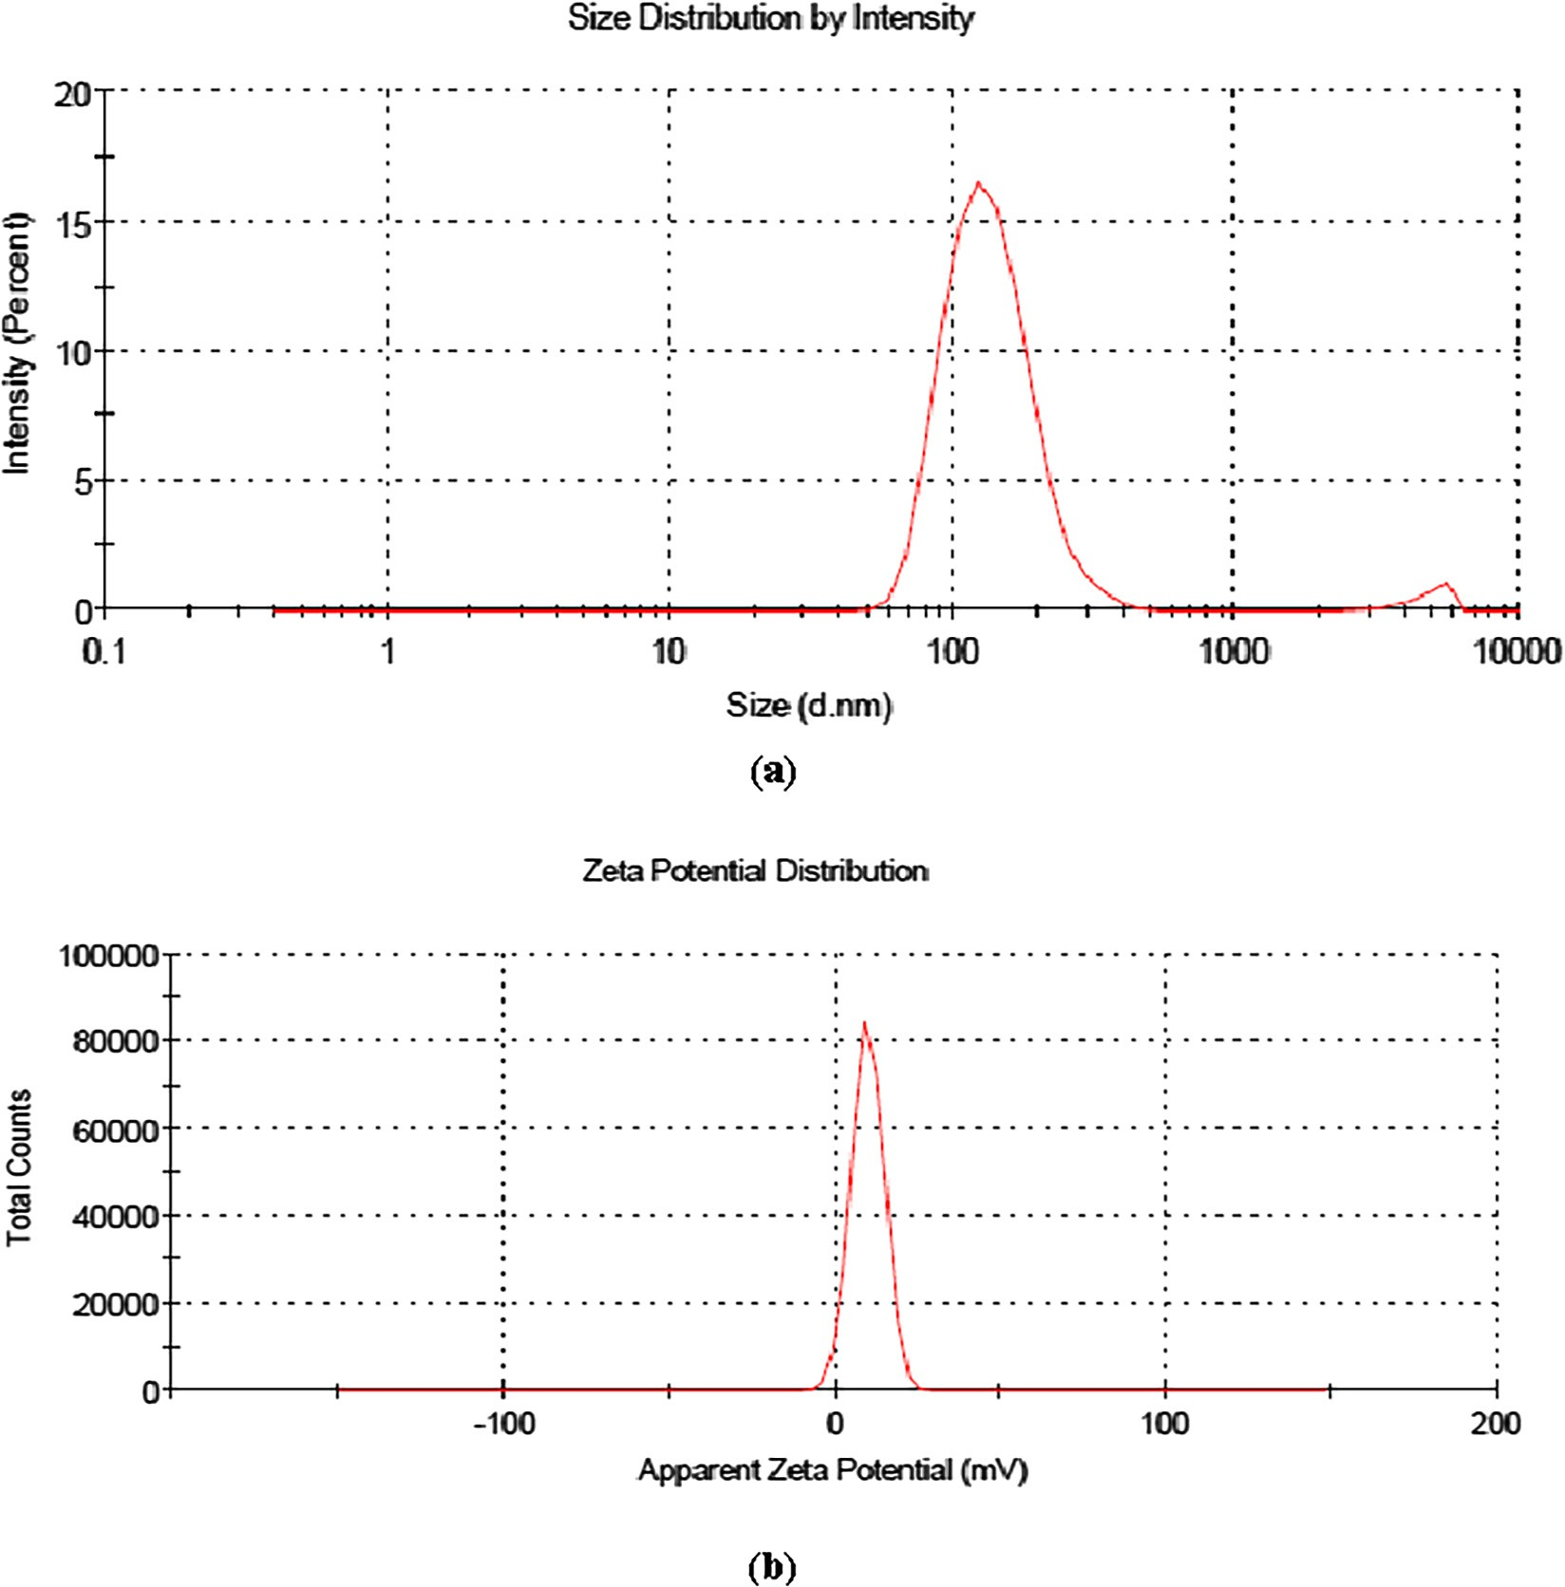

Fig. 1. Vincristine loaded folic acid-chitosan conjugated nanoparticles of 4:25 formulation (a) average size and polydispersity index, and, (b) and zeta potential.

Table 2

Encapsulation efficiency (%) and loading capacity (%) of vincristine loaded folic acid- chitosan conjugated nanoparticles.

|  |  |  |  |
| --- | --- | --- | --- |
| S. No. | Formulations | Encapsulation efficiency (%) | Loading capacity (%) |
| 1. | 1:25 | 50 ± 0.58 | 10.90 ± 0.45 |
| 2. | 2:25 | 70 ± 0.50 | 12.24 ± 0.51 |
| 3. | 3:25 | 80 ± 0.45 | 25.40 ± 0.38 |
| 4. | 4:25 | 95 ± 0.35 | 48.65 ± 0.47 |

± Standard deviation (n = 3).

Table 3

Effect of storage on average size, polydispersity index and zeta potential of blank and vincristine loaded folic acid-chitosan conjugated nanoparticles in sodium phosphate buffer (pH 7.4) at 4 °C after 10 days.

Formulations After 10 days

gated nanoparticles. An increase in the size of chitosan/ tripolyphosphate nanoparticles stored in a phosphate buffer (pH 7.4) at 25 °C over a period of 10 days has been observed [26].

* + 1. *Fourier Transform Infrared Spectroscopy*

nanoparticles showed a characteristic peak at 3338.52 cm—1 due The FTIR spectrum of blank folic acid-chitosan conjugated 3326.54, 3355.91 and 3709.102 cm—1 for 1:25, 2:25, 3:25 and to N-H stretching vibration, which was shifted to 3336.79,

3709.102 cm—1 demonstrated that inter- and intra-molecular 4:25 formulations, respectively (Fig. 2a–e). Wider peak at interactions were enhanced in folic acid-chitosan nanoparticles

because of tripolyphosphoric groups of sodium tripolyphosphate linked with ammonium group of folic acid-chitosan conjugate [27]. Shifting in peaks at 1549.82, 1549.61, 1552.93 and 1551.94

cm—1 due to Amide II N-H deformation and C-N stretching vibra-

Average size (nm) Polydispersity

index

Zeta potential (mV)

tion could be a consequence of loading of vincristine in nanoparticles.

|  |  |  |  |  |
| --- | --- | --- | --- | --- |
| Blank FA-CS 1:25 | NPs 203.0 ± 0.50  220.0 ± 0.96 | 0.329 ± 0.10  0.259 ± 0.45 | +3.94 ± 0.25  +2.76 ± 0.35 | *3.3.5. Scanning electron microscopy (SEM)* |
| 2:25 | 341.1 ± 0.58 | 0.611 ± 0.09 | +3.74 ± 0.40 | Different sized nanoparticles with spherical shape and rough |
| 3:25  4:25 | 225.3 ± 0.34  208.2 ± 0.43 | 0.547 ± 0.04  0.336 ± 0.03 | +4.25 ± 0.80  +3.83 ± 0.28 | surface were observed by scanning electron microscopy (Fig. 3). However, there were difference in the size of nanoparticles as com- |

± Standard deviation (n = 3).

pared with dynamic light scattering (DLS) due to different tech-

niques used for preparation of nanoparticles for analysis. The nanoparticles in 4:25 formulation looked more rough in appear- ance, which might be due to maximum loading of vincristine in these. In contrast, Panwar et al. [28] observed smooth and spheri- cal shaped ferulic acid-loaded chitosan nanoparticles and checked anticancer activity against ME-180 human cervical cancer cell lines. They observed significant inhibition in ME-180 cells and con-

cluded that these nanoparticles can be used to treat cervical can- cer. Anitha et al. [29] also observed spherical morphology of curcumin-loaded N,O-carboxymethyl chitosan nanoparticles and checked anticancer activity against normal (L929) and breast can- cer cell line (MCF-7). The authors reported non-toxicity of nanoparticles against L929 cells, whereas enhanced toxicity was found against MCF-7 cells. In another report, Mehrotra et al. [30]

98.9

2132,96

1414,92

1637,74

3338,52

95

90

85

80

75

%T

70

65

60

55

50

47.0

4000.0 3600 3200 2800 2400 2000 1800 1600 1400 1200 1000 800 650.0

cm-1

## (a)

98.9

2152,97

1018,96

1641,89

1411,85

1549,82

3336,79

98

96

94

92

90

88

%T

86

84

82

80

78

77.0

4000.0 3600 3200 2800 2400 2000 1800 1600 1400 1200 1000 800 650.0

cm-1

## (b)

100.2

1118,97

2152,96

1018,93

1346,90

1641,75

1412,67

1549,61

3326,54

95

90

85

80

75

%T

70

65

60

55

50

48.0

4000.0 3600 3200 2800 2400 2000 1800 1600 1400 1200 1000 800 650.0

cm-1

## (c)

Fig. 2. FTIR spectra showing shifting in peaks due to loading of vincristine (a) blank FA-CS NPs and vincristine loaded FA-CS NPs at different formulations, (b) 1:25, (c) 2:25,

(d) 3:25, (e) 4:25

98.6

1343,97

1643,95

1412,94

1552,93

3355,91

98

97

96

95

%T

94

93

92

91

90.4

4000.0 3600 3200 2800 2400 2000 1800 1600 1400 1200 1000 800 650.0

cm-1

# (d)

104.3

3709,102

2975,100

1551,94

1405,93

103

102

101

100

99

%T 98

97

96

95

94

93

92.0

4000.0 3600 3200 2800 2400 2000 1800 1600 1400 1200 1000 800 650.0

cm-1

# (e)

Fig. 2 (*continued*)

observed spherical shaped and smooth surfaced lomustine loaded chitosan sodium tripolyphosphate and chitosan-sodium hexam- etaphosphate nanoparticles.

* + 1. *Transmission electron microscopy (TEM)*

As shown in Fig. 4, blank and vincristine loaded FA-CS nanopar- ticles were spherical in shape. As compared to blank FA-CS nanoparticles, granule like structures were present in nanoparti- cles of 1:25, 2:25, 3:25 and 4:25 formulations due to loading of vincristine. However, there were difference in the size of nanopar- ticles as compared with SEM due to more dilutions of sample used for preparation of nanoparticles for analysis in TEM. Earlier, Salar and Kumar [14] observed spherical shaped vincristine loaded folic acid-chitosan conjugated nanoparticles with granule like structure due to loading of vincristine. Similarly, spherical shaped mitox- antrone loaded folic acid-chitosan conjugated nanoparticles has also been observed [19].

* + 1. *In vitro release study*

As shown in Fig. 5, 1:25 formulation showed 16.67% cumulative release of vincristine within 2 h and subsequently 16.71, 33.33 and 33.37% after 4, 6 and 8 h, respectively. As compared to this, 2:25

formulation showed 16.31% release within 2 h and 16.67, 16.71,

27.33% release after 4, 6 and 8 h, respectively. Similarly, a formu-

lation of 3:25 showed 6.25% release within 2 h and after 4, 6, 8 h

release was 6.07, 6.09, 12.5%, respectively. Finally, 4:25 formula-

tion showed 5.51% release of vincristine within 2 h and subse- quent release was 5.47, 5.57, 11.11% after 4, 6, 8 h, respectively from folic acid-chitosan conjugated nanoparticles. It can be con- cluded that, except 1:25, all formulations showed slow and sus- tained release of vincristine. Similarly, Wang et al. [19] observed slow release of mitoxantrone loaded in folic acid-chitosan conju- gated nanoparticles in artificial gastric liquid (pH 1.2) and intesti- nal fluid (pH 6.8).

* + 1. *Uptake of vincristine loaded FA-CS nanoparticles by NCI-H460 cells*

Visual evidence of vincristine loaded folic acid-chitosan nanoparticles (4:25) uptake by the NCI-H460 cells during 45 min- utes incubation time at 37 °C was analyzed by fluorescence micro- scopy using Hoechst 33258 dye. NCI-H460 cells showed diminished fluorescence when grown in RPMI-1640 medium.

However, when cells were treated with vincristine loaded folic acid-chitosan conjugated nanoparticles (100 ml), brighter fluores-

cence was observed at 40× magnifications due to uptake of

nanoparticles (Fig. 6). Since, Hoechst 33258 is a blue fluorescent

dye used to stain DNA of cells, the fluorescence was observed due to uptake of nanoparticles by cells and their action on DNA. Similarly, Karthikeyan et al. [17] also observed brighter blue fluo- rescence in NCI-H460 non-small cell lung cancer cells treated with resveratrol loaded gelatin nanoparticles than free resveratrol using Hoechst 33258 dye during 30 minutes incubation time.

* + 1. *Anticancer activity of vincristine loaded FA-CS nanoparticles*

Table 4 shows the percent cytotoxicity of blank and vincristine loaded folic acid-chitosan conjugated nanoparticles (5, 10, 15, 20, 25 mg/ml) in NCI-H460 cells. For blank nanoparticles, the lowest cell viability (40.25%) was observed at 20 mg/ml concentration. In comparison, vincristine loaded FA-CS nanoparticles showed lowest cell viability (32.78%) at 10 mg/ml concentration. Hence the inhibitory concentration 50 (IC50) was fixed as 10 mg/ml for blank and 5 mg/ml for vincristine loaded folic acid-chitosan conjugated nanoparticles because at these concentrations, the NCI-H460 non-small cell lung cancer cell line can be used to check intracellular ROS level, changes in mitochondrial transmembrane potential and apoptotic morphological changes without causing damage to cells. For group 1: untreated control cells in RPMI- 1640 medium and group 2: untreated control cells in PBS (pH

7.4) with RPMI-1640 medium, almost 100% cell viability was observed, hence not included in the table. Similarly, Wang et al.

[31] determined the cytotoxicity of free 5-fluorouracil and 5- fluorouracil loaded hyaluronic acid coated chitosan nanoparticles of different concentrations against A549 cells and HepG2 cells. The results showed that the naked hyaluronic acid-coated chitosan nanoparticles at a concentration (ranging from 0.1 to 1.0 mg/mL) did not inhibit the proliferation of A549 and HepG2 cells, and viability ratios were over 85%. Compared with 5- fluorouracil and 5-fluorouracil-loaded uncoated chitosan nanopar- ticles, 5-fluorouracil-loaded hyaluronic acid-coated chitosan nanoparticles showed higher cytotoxicity in A549 and HepG2 cells, which was 50% maximal inhibitory concentration (IC50) at

8.0 and 6.7 lg/mL at 48 h, respectively. The cytotoxic effect of hyaluronic acid-coated chitosan nanoparticles was reduced to

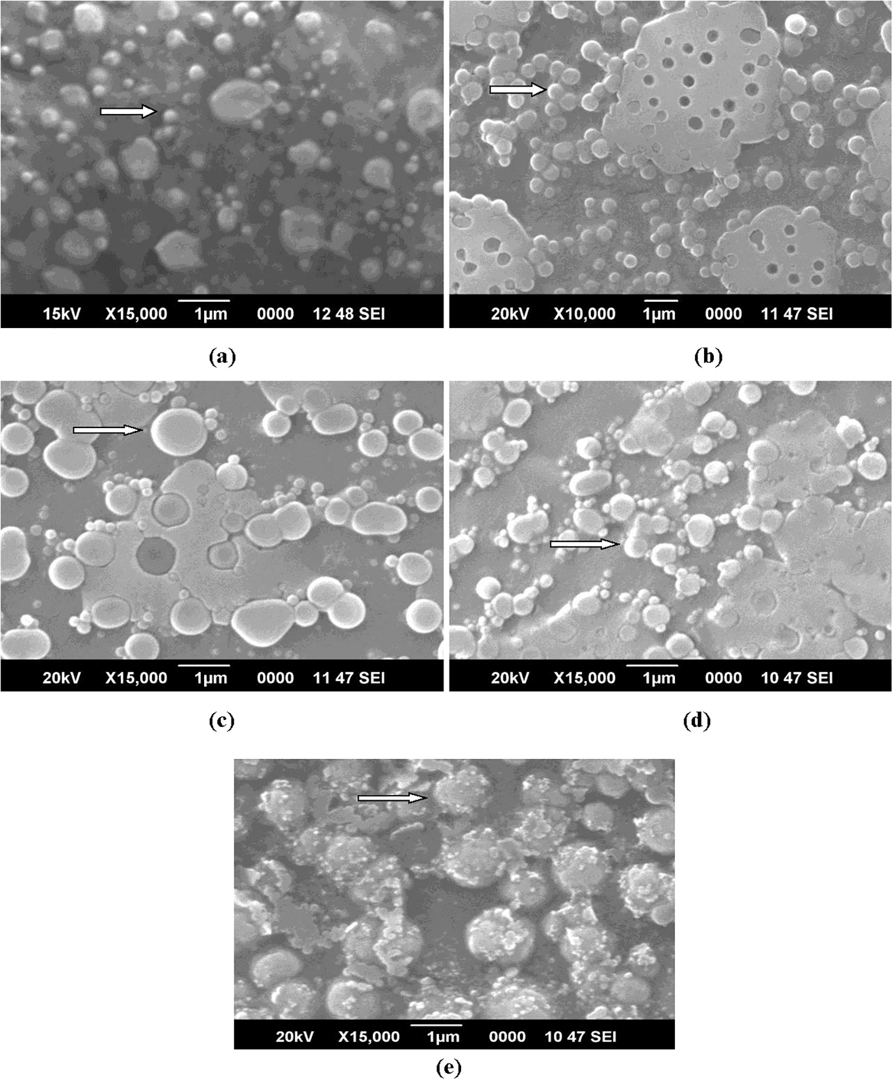

Fig. 3. SEM images of nanoparticles showing spherical shaped (a) blank FA-CS NPs and vincristine loaded FA-CS NPs at different formulations, (b) 1:25, (c) 2:25, (d) 3:25, (e) 4:25.

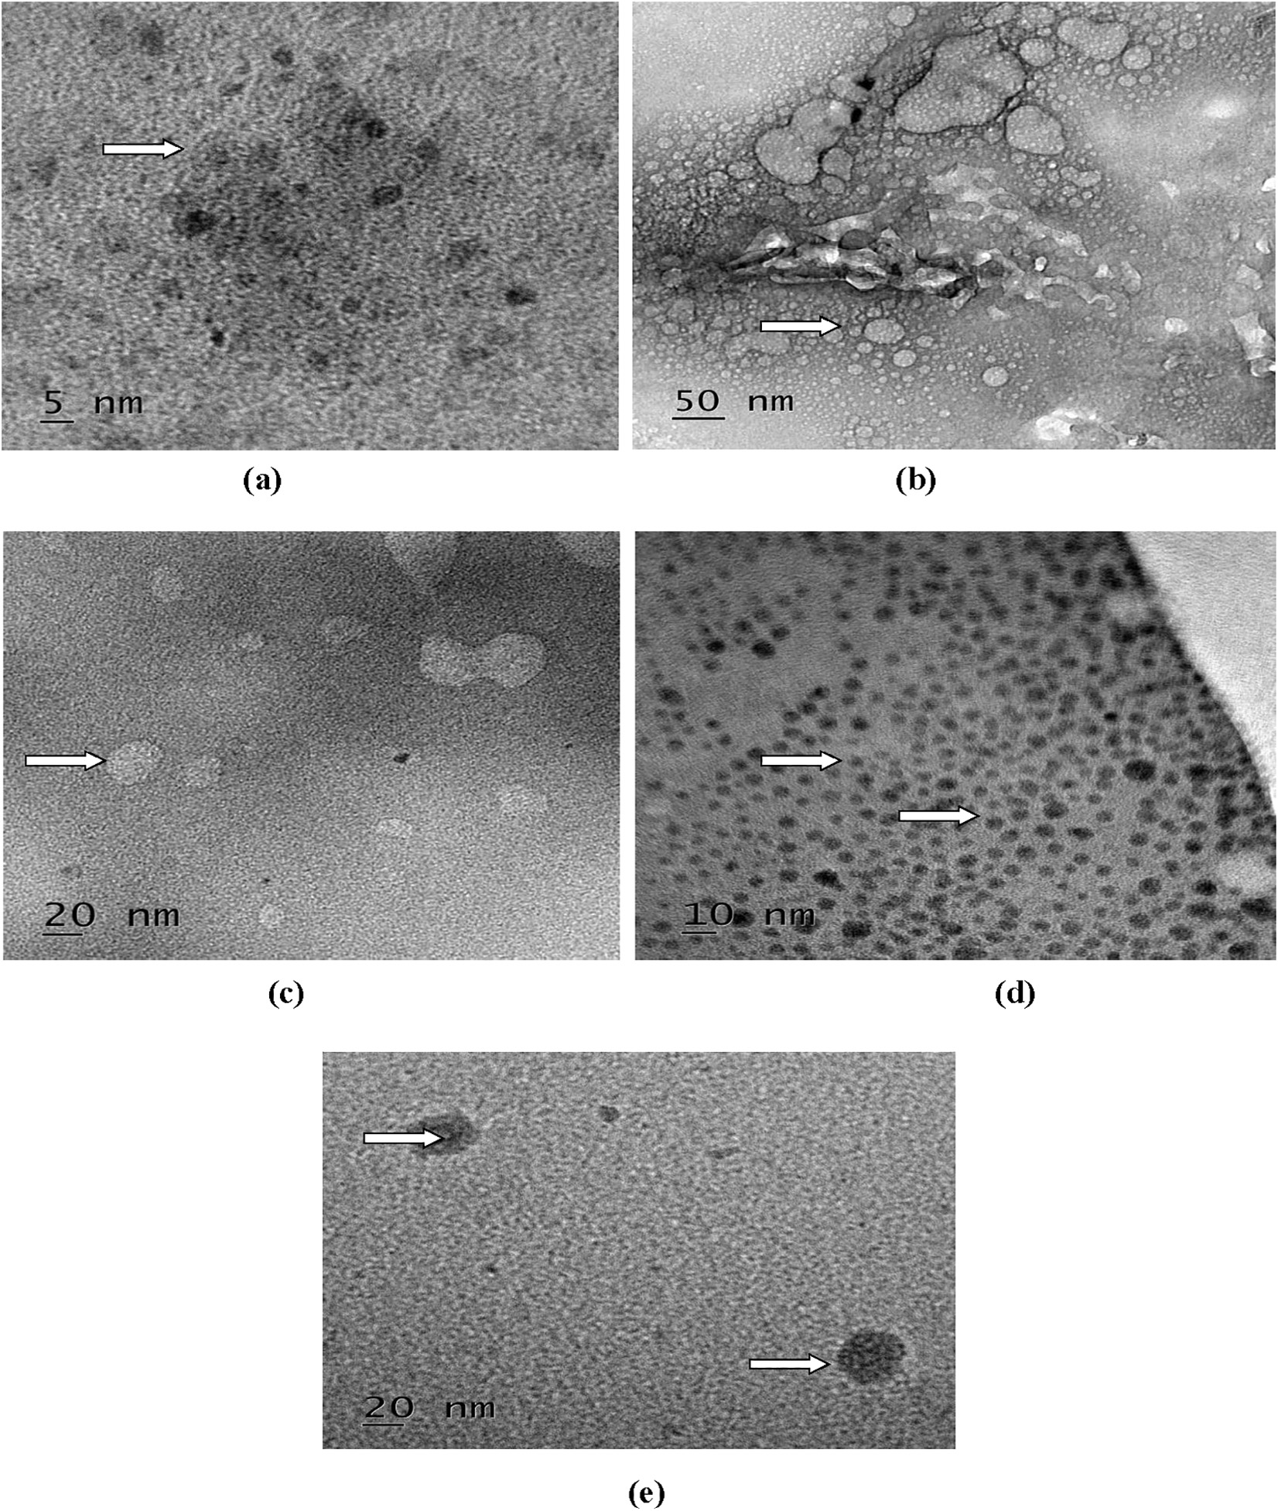

Fig. 4. Transmission electron microphotographs of blank and vincristine loaded FA-CS nanoparticles showing encapsulation of vincristine (arrows) (a) blank and different formulations, (b) 1:25, (c) 2:25, (d) 3:25, (e) 4:25.

13.1 lg/mL at 48 h against A549 cells whereas, addition of free hyaluronic acid had no obvious effects on the HepG2 cells. Anitha et al. [29] studied *in vitr*o cytotoxicity of curcumin and curcumin- N,O-carboxymethyl chitosan nanoparticles in a normal (L929), human breast cancer (MCF-7) and prostate cancer cell line (PC- 3). L929 cell line treated with N,O-carboxymethyl chitosan nanoparticles showed high cell viability within concentration range of 1–5 mg/ml, whereas reduced cell viability was observed with curcumin and curcumin loaded N,O-carboxymethyl chitosan nanoparticles in the same concentration. However, 80% of the cell viability indicated the non-toxicity of curcumin, N,O- carboxymethyl chitosan nanoparticles and curcumin loaded N,O- carboxymethyl chitosan nanoparticles towards normal cells. For MCF-7 cells, N,O-carboxymethyl chitosan nanoparticles showed no toxicity, whereas curcumin and curcumin N,O-carboxymethyl nanoparticles showed considerable toxicity. Similarly, in PC-

3 cells, curcumin-N,O-carboxymethyl chitosan nanoparticles showed toxicity, as a result of which cell viability was reduced to 30% at 5 mg/ml concentration, confirmed its anticancer effects.

* + 1. *Determination of intracellular ROS level*

As shown in (Fig. 7i), weak ROS generation was observed in the untreated NCI-H460 cells. In contrast, blank nanoparticles showed significant ROS production and a further enhanced ROS generation, was found in vincristine loaded folic acid-chitosan conjugated nanoparticles (Fig. 7i). Similarly, Hou et al. [32] observed ROS level in human lung carcinoma (A549) and cervical cancer cell line (HeLa) treated with triphenyl phosphine-functionalized chitosan nanoparticles through targeted delivery of doxorubicin to mito- chondria. The results demonstrated that ROS levels in A549 and HeLa cells exposed to free doxorubicin showed a certain enhance- ment and were increased to 120.5% in 24 h and 130.4% after 48 h in

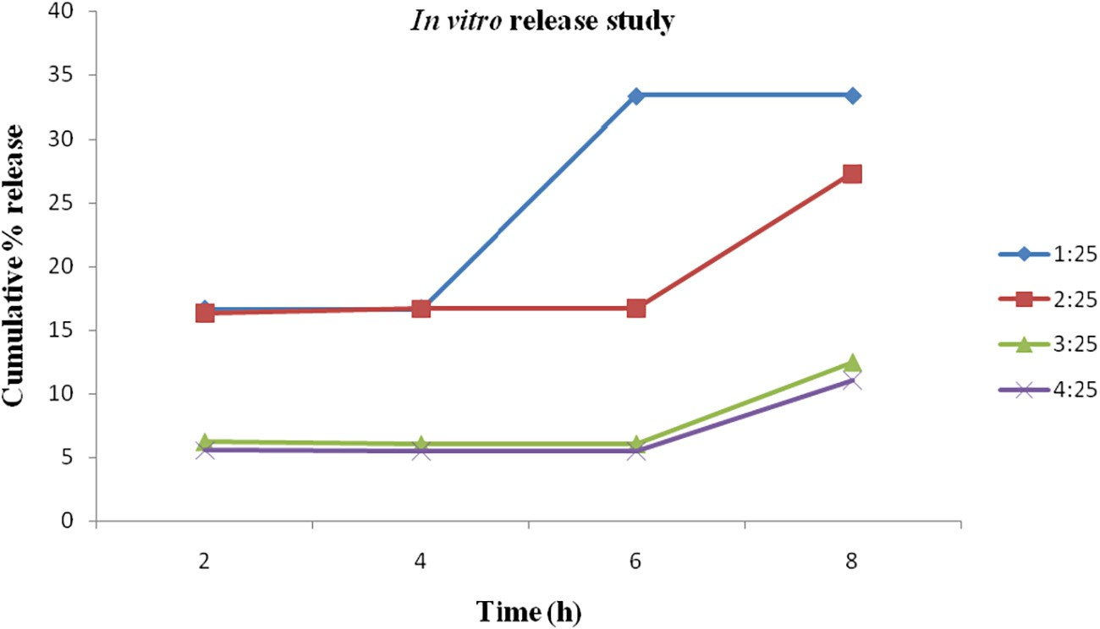

Fig. 5. Cumulative release (%) behavior of vincristine from folic acid-chitosan conjugated nanoparticles for different formulations (1:25, 2:25, 3:25, 4:25) showing slow and sustained release in phosphate buffered saline (pH 6.7).

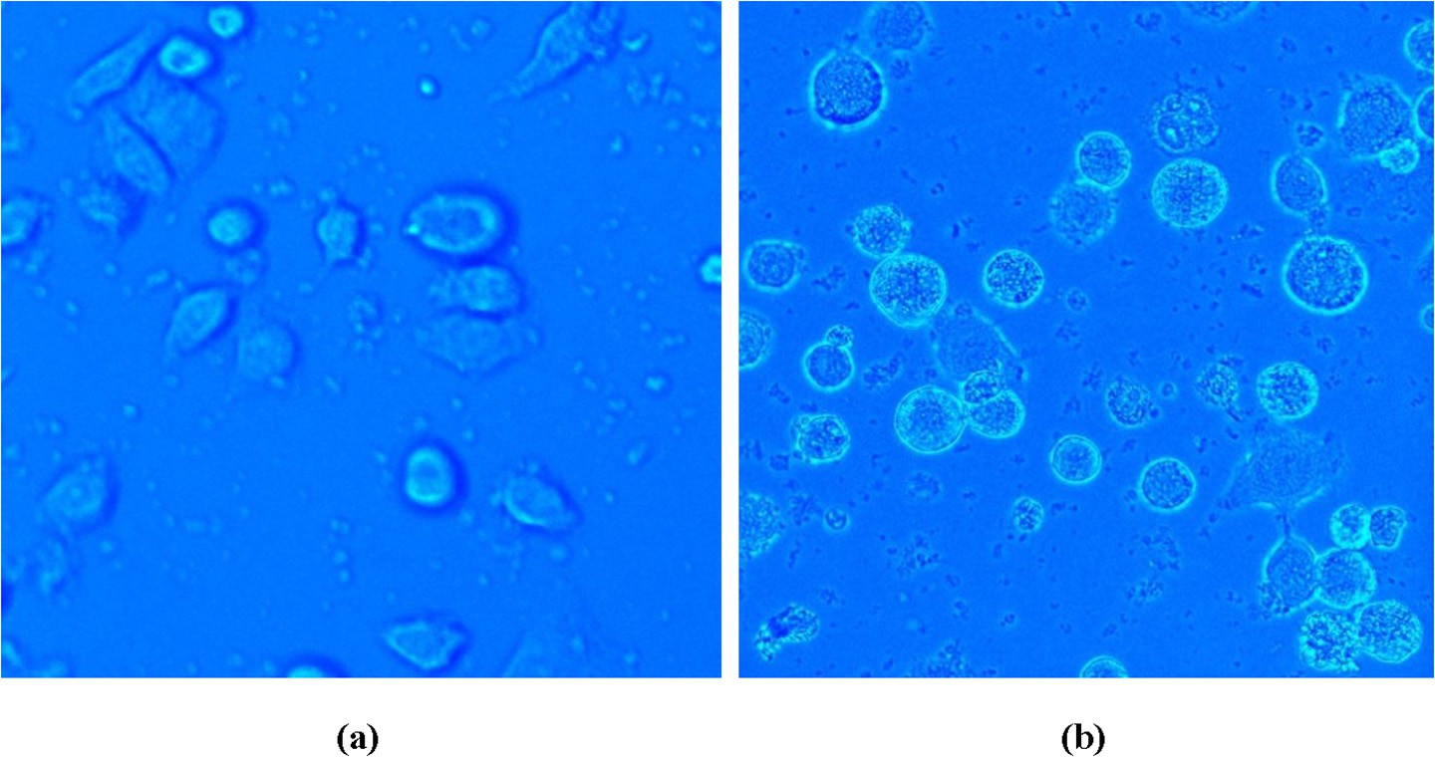Fig. 6. Cellular uptake of nanoparticles in NCI-H460 cells 40× (a) control, (b) enhanced fluorescence with vincristine loaded folic acid-chitosan conjugated nanoparticles.

A549 cells in comparison with 130.4% in 24 h and 136.7% after 48 h in HeLa cells. In the same way, doxorubicin-loaded triphenyl phosphine-functionalized chitosan nanoparticles also triggered ROS levels at 168.4% in 24 h and 180.4% after 48 h in A549 cells, and 150.1% in 24 h and 166.5% after 48 h in HeLa cells.

* + 1. *Determination of changes in mitochondrial transmembrane potential*

NCI-H460 cells treated with blank FA-CS nanoparticles and untreated control cells (Fig. 7ii) showed blue fluorescence due to accumulation of Rh-123 dye. However, no Rh-123 accumulation

Table 4

Cell viability (%) of blank and vincristine loaded FA-CS nanoparticles at different concentrations.

was found in vincristine loaded folic acid-chitosan conjugated nanoparticles treated cells (Fig. 7ii). Hence, mitochondrial mem- brane potential has been found to be reduced in the cells treated with vincristine loaded FA-CS nanoparticles. Karthikeyan et al.

[17] observed reduced mitochondrial membrane potential in NCI-H460 cells treated with resveratrol-loaded gelatin nanoparti- cles as compared to resveratrol. They found accumulation of Rh- 123 dye in the control group whereas, resveratrol-loaded gelatin nanoparticles treated cells showed decreased membrane potential.

* + 1. *Determination of apoptotic morphological changes*

Very less morphological changes associated with acridine orange and ethidium bromide were observed in control and NCI- H460 cells treated with blank FA-CS nanoparticles (Fig. 7iii). When NCI-H460 cells were treated with vincristine loaded folic acid-

chitosan conjugated nanoparticles (5 mg/ml, 50 ml), apoptotic fea-

S. No. Concentration

(mg/ml)

Cell viability (%)

Blank FA-CS NPs Vincristine loaded FA-CS NPs

tures with differential staining of acridine orange and ethidium bromide were observed. This showed that vincristine loaded folic

1. 5 87.14 46.47

2. 10 71.49 32.78

3. 15 52.89 43.15

4. 20 40.25 38.17

5. 25 47.25 36.51

acid chitosan conjugated nanoparticles were more effective than blank nanoparticles. Finally, vincristine loaded folic acid-chitosan conjugated nanoparticles showed 75% of apoptotic cells, whereas for blank 31% cells were observed with apoptosis. Karthikeyan et al. [17] observed apoptotic features with condensed or frag-

## (i) (ii) (iii)

Blank FA-CS NPs

Cells

**(c)**

Vincristine loaded

FA-CS NPs

Fig. 7. Fluorescent micrographs showing effect of nanoparticles in NCI-H460 cells (i) intracellular ROS level, (ii) mitochondrial transmembrane potential, (iii) apoptotic morphological changes.

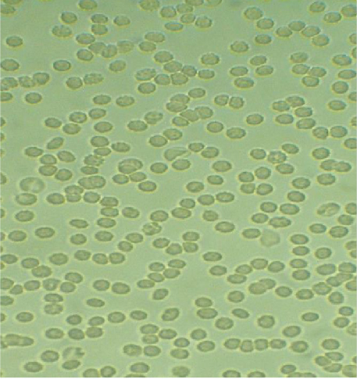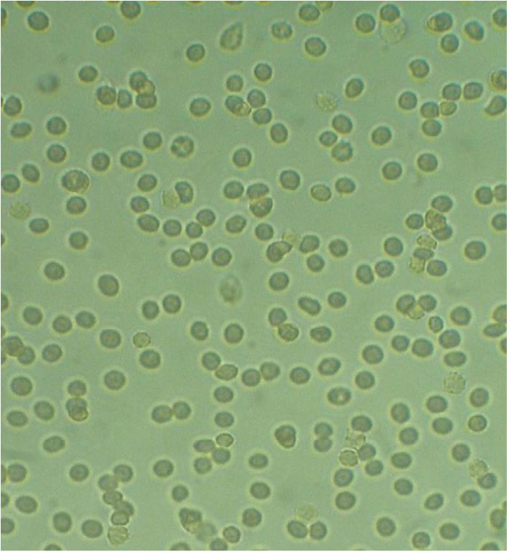

**(a) (b)**

Fig. 8. Light microphotographs of erythrocytes aggregation (a) control, (b) vincristine loaded folic acid-chitosan conjugated nanoparticles.

mented chromatin, indicative of apoptosis in resveratrol and resveratrol-loaded gelatin nanoparticles treated NCI-H460 cells. Resveratrol-loaded gelatin nanoparticles treated NCI-H460 cells showed 98% apoptosis, whereas free resveratrol treatment showed only 42% apoptotic cells. Similarly, Panwar et al. [28] determined apoptotic morphological changes of ferulic acid-loaded chitosan nanoparticles against human cervical cancer cell line (ME-180) with acridine orange (AO) and ethidiumbromide (EtBr) staining. Cells treated with ferulic acid chitosan-tripolyphosphate penta- sodium nanoparticles (40 mM) for 24 h displayed morphological

characteristics such as higher cell shrinkage, cytoplasmic conden-

sation, and irregularity in shape, suggested that ferulic acid- loaded chitosan nanoparticles could induce apoptotic cell death in ME-180 cells. The morphology and growth of cancer cells cul- tured on unloaded chitosan-tripolyphosphate pentasodium nanoparticles were negligibly affected as compared to control.

1. Erythrocyte aggregation assay

As shown in Fig. 8(a), fresh erythrocytes were spherical in shape. After treatment with vincristine loaded folic acid-chitosan conjugated nanoparticles (400 ml, 4:25 formulation) in phosphate

buffered saline (PBS, pH 7.4) for 1 h at 37 °C, no aggregation of ery-

throcytes was reported as shown in Fig. 8(b). This showed that 4:25 formulation was safe for erythrocytes. Similarly, Karthikeyan et al. [17] also observed no aggregation of erythrocytes when trea- ted with resveratrol-loaded gelatin nanoparticles.

1. Conclusion

In this study, vincristine was loaded in folic acid-chitosan con- jugated nanoparticles in different formulations i.e. 1:25, 2:25, 3:25, 4:25 at pH 5. Maximum encapsulation efficiency (%) and loading capacity (%) was observed for 4:25 formulation i.e. 95 ± 0.35 and

48.65 ± 0.47, respectively. Scanning electron microscopy showed spherical structure with rough surfaced nanoparticles. Fourier transform infrared spectroscopy (FTIR) and Transmission electron microscopy (TEM) confirmed encapsulation of vincristine in nanoparticles. Attachment of folic acid, size of nanoparticles below 200 nm in all formulations with positive zeta potential favored tar- geted delivery of vincristine to cancer cells. Anticancer activity of vincristine loaded folic acid chitosan nanoparticles in 4:25 formu- lation was checked against non-small cell lung cancer cell line (NCI-H460). MTT assay showed greater cytotoxicity of vincristine loaded folic acid chitosan conjugated nanoparticles as compared to blank. Enhanced ROS generation, decreased mitochondrial transmembrane potential and apoptotic morphological changes associated with NCI-H460 cells showed effectiveness of vincristine loaded folic acid-chitosan conjugated nanoparticles in the treat- ment of NCI-H460 cells. No aggregation of erythrocytes was reported when treated with vincristine loaded folic acid-chitosan conjugated nanoparticles. Hence vincristine loaded folic acid- chitosan conjugated nanoparticles in 4:25 formulation can be used for treatment of NCI-H460 cells.

Acknowledgements

The authors acknowledge Central Instrumentation Laboratory and Sophisticated Analytical Instrumentation Facility, Panjab University, Chandigarh for help in FTIR and XRD analyses, respec- tively. Authors are thankful to Sophisticated Test & Instrumenta- tion Centre, Cochin University of Science and Technology, Cochin for help in SEM and TEM analysis. The authors also acknowledge Prof. Tibor Hianik and Zuzana Garaiova, Department of Nuclear Physics and Biophysics, Faculty of Mathematics, Physics and Infor-

matics, Comenius University, Bratislava, Slovak Republic for help in average size, polydispersity index, zeta potential measurements. Naresh Kumar gratefully acknowledges Slovak Academic Informa- tion Agency, Bratislava for awarding National Scholarship under National Scholarship Programme approved by the Government of the Slovak Republic to carry out some part of research work at Slo- vakia and University Research Scholarship from Chaudhary Devi Lal University, Sirsa, Haryana.

References

1. Ferlay J, Soerjomataram I, Ervik M, Dikshit R, Eser S, Mathers C, et al. GLOBOCAN 2012 v1.0, Cancer Incidence and Mortality Worldwide: IARC CancerBase No. 11. Lyon, France: International Agency for Research on Cancer; 2012.
2. [Travis WD, Travis LB, Devesa SS. Lung cancer. Cancer 1995;75:191–202](http://refhub.elsevier.com/S2314-808X(17)30381-0/h0010).
3. [Costa G, Hreshchyshyn MM, Holland JF. Initial clinical studies with vincristine.](http://refhub.elsevier.com/S2314-808X(17)30381-0/h0015) [Cancer Chemother Rep 1962;24:39–44](http://refhub.elsevier.com/S2314-808X(17)30381-0/h0015).
4. [Johnson IS, Armstrong JG, Gorman M, Burnett Jr JP. The vinca alkaloids: a new](http://refhub.elsevier.com/S2314-808X(17)30381-0/h0020) [class of oncolytic agents. Cancer Res 1963;23:1390–427](http://refhub.elsevier.com/S2314-808X(17)30381-0/h0020).
5. Vincristine sulfate. The American Society of Health-System Pharmacists [retrieved 11.07.17].
6. Ravina E. The evolution of drug discovery: from traditional medicines to modern drugs. 1 Aufl Ed. Weinheim; 2011, p. 157–15.
7. [Kumar MR, Muzzarelli RA, Muzzarelli C, Sashiwa H, Domb A. Chitosan](http://refhub.elsevier.com/S2314-808X(17)30381-0/h0035) [chemistry and pharmaceutical perspectives. Chem Rev 2004;104:6017–84](http://refhub.elsevier.com/S2314-808X(17)30381-0/h0035).
8. [Ilium L. Chitosan and its use as a pharmaceutical excipient. Pharm Res](http://refhub.elsevier.com/S2314-808X(17)30381-0/h0040) [1998;15:1326–31](http://refhub.elsevier.com/S2314-808X(17)30381-0/h0040).
9. [Felt O, Buri P, Gurny R. Chitosan: a unique polysaccharide for drug delivery.](http://refhub.elsevier.com/S2314-808X(17)30381-0/h0045) [Drug Dev Ind Pharm 1998;24:979–93](http://refhub.elsevier.com/S2314-808X(17)30381-0/h0045).
10. [Kean T, Thanou M. Chitin and chitosan-sources, production and medical](http://refhub.elsevier.com/S2314-808X(17)30381-0/h0050) [applications. In: Williams PA, Arshady R, editors. Desk reference of natural](http://refhub.elsevier.com/S2314-808X(17)30381-0/h0050) [polymers, their sources, chemistry and applications. London: Kentus Books;](http://refhub.elsevier.com/S2314-808X(17)30381-0/h0050) [2009. p. 327–61](http://refhub.elsevier.com/S2314-808X(17)30381-0/h0050).
11. [Mourya VK, Inamdar NN. Chitosan-modifications and applications:](http://refhub.elsevier.com/S2314-808X(17)30381-0/h0055) [opportunities galore. React Funct Polym 2008;68:1013–51](http://refhub.elsevier.com/S2314-808X(17)30381-0/h0055).
12. [Subramanian A, Rau AV, Kaligotla H. Surface modification of chitosan for](http://refhub.elsevier.com/S2314-808X(17)30381-0/h0060) [selective surface-protein interaction. Carbohydr Polym 2006;66:321–32](http://refhub.elsevier.com/S2314-808X(17)30381-0/h0060).
13. [Byrne JD, Betancourt T, Brannon-Peppas L. Active targeting schemes for](http://refhub.elsevier.com/S2314-808X(17)30381-0/h0065) [nanoparticle systems in cancer therapeutics. Adv Drug Deliv Rev](http://refhub.elsevier.com/S2314-808X(17)30381-0/h0065) [2008;60:1615–26](http://refhub.elsevier.com/S2314-808X(17)30381-0/h0065).
14. [Salar RK, Kumar N. Synthesis and characterization of vincristine loaded folic](http://refhub.elsevier.com/S2314-808X(17)30381-0/h0070) [acid–chitosan conjugated nanoparticles. Res Eff Technol 2016;2:199–214](http://refhub.elsevier.com/S2314-808X(17)30381-0/h0070).
15. [Calvo P, Remunan Lopez C, VilaJato JL, Alonso MJ. Novel hydrophilic chitosan-](http://refhub.elsevier.com/S2314-808X(17)30381-0/h0075) [polyethylene oxide nanoparticles as protein carriers. J Appl Polym Sci](http://refhub.elsevier.com/S2314-808X(17)30381-0/h0075) [1997;63:125–32](http://refhub.elsevier.com/S2314-808X(17)30381-0/h0075).
16. [Mosmann T. Rapid colorimetric assay for cellular growth and survival:](http://refhub.elsevier.com/S2314-808X(17)30381-0/h0080) [application to proliferation and cytotoxicity assays. J Immunol Methods](http://refhub.elsevier.com/S2314-808X(17)30381-0/h0080) [1983;65:55–63](http://refhub.elsevier.com/S2314-808X(17)30381-0/h0080).
17. [Karthikeyan S, Rajendra Prasad N, Ganamani A, Balamurugan E. Anticancer](http://refhub.elsevier.com/S2314-808X(17)30381-0/h0085) [activity of resveratrol-loaded gelatin nanoparticles on NCI-H460 non-small](http://refhub.elsevier.com/S2314-808X(17)30381-0/h0085) [cell lung cancer cells. Biomed Prev Nutr 2013;3:64–73](http://refhub.elsevier.com/S2314-808X(17)30381-0/h0085).
18. [Ji J, Wu D, Liu L, Chen J, Xu Y. Preparation, characterization, and *in vitro* release](http://refhub.elsevier.com/S2314-808X(17)30381-0/h0090) [of folic acid-conjugated chitosan nanoparticles loaded with methotrexate for](http://refhub.elsevier.com/S2314-808X(17)30381-0/h0090) [targeted delivery. Polym Bull 2012;68:1707–20](http://refhub.elsevier.com/S2314-808X(17)30381-0/h0090).
19. [Wang W, Tong C, Liu X, Li T, Liu B, Xiong W. Preparation and functional](http://refhub.elsevier.com/S2314-808X(17)30381-0/h0095) [characterization of tumor-targeted folic acid-chitosan conjugated](http://refhub.elsevier.com/S2314-808X(17)30381-0/h0095) [nanoparticles loaded with mitoxantrone. J Cent South Univ 2015;22:3311–7](http://refhub.elsevier.com/S2314-808X(17)30381-0/h0095).
20. [Naghibi Beidokhti HR, Ghaffarzadegan R, Mirzakhanlouei S, Ghazizadeh L,](http://refhub.elsevier.com/S2314-808X(17)30381-0/h0100) [Dorkoosh FA. Preparation, characterization, and optimization of folic acid-](http://refhub.elsevier.com/S2314-808X(17)30381-0/h0100) [chitosan-methotrexate core-shell nanoparticles by Box-Behnken design for](http://refhub.elsevier.com/S2314-808X(17)30381-0/h0100) [tumor-targeted drug delivery. AAPS PharmSciTech 2017;18:115–29](http://refhub.elsevier.com/S2314-808X(17)30381-0/h0100).
21. [Selvi Gunel N, Ozel B, Kipcak S, Aktan C, Akgun C, Ak G, et al. Synthesis of](http://refhub.elsevier.com/S2314-808X(17)30381-0/h0105) [methotrexate loaded chitosan nanoparticles and *in vitro* evaluation of the](http://refhub.elsevier.com/S2314-808X(17)30381-0/h0105) [potential in treatment of prostate cancer. Anticancer Agents Med Chem](http://refhub.elsevier.com/S2314-808X(17)30381-0/h0105) [2016;16:1038–42](http://refhub.elsevier.com/S2314-808X(17)30381-0/h0105).
22. [Maeda H, Wu J, Sawa T, Matsumura Y, Hori K. Tumor vascular permeability](http://refhub.elsevier.com/S2314-808X(17)30381-0/h0110) [and the EPR effect in macromolecular therapeutics: a review. J Control Release](http://refhub.elsevier.com/S2314-808X(17)30381-0/h0110) [2000;65:271–84](http://refhub.elsevier.com/S2314-808X(17)30381-0/h0110).
23. [Owens IIIrd DE, Peppas NA. Opsonization, biodistribution, and](http://refhub.elsevier.com/S2314-808X(17)30381-0/h0115) [pharmacokinetics of polymeric nanoparticles. Int J Pharm 2006;307:93–102](http://refhub.elsevier.com/S2314-808X(17)30381-0/h0115).
24. [Sun L, Chen Y, Zhou Y, Guo D, Fan Y, Guo F, et al. Preparation of 5-fluorouracil-](http://refhub.elsevier.com/S2314-808X(17)30381-0/h0120) [loaded chitosan nanoparticles and study of the sustained release *in vitro* and](http://refhub.elsevier.com/S2314-808X(17)30381-0/h0120) [*in vivo*. Asian J Pharm Sci 2017;12:418–23](http://refhub.elsevier.com/S2314-808X(17)30381-0/h0120).
25. [Xu S, Xu Q, Zhou J, Wang J, Zhang N, Zhang L. Preparation and characterization](http://refhub.elsevier.com/S2314-808X(17)30381-0/h0125) [of folate-chitosan-gemcitabine core-shell nanoparticles for potential tumor-](http://refhub.elsevier.com/S2314-808X(17)30381-0/h0125) [targeted drug delivery. J Nanosci Nanotechnol 2013;13:129–38](http://refhub.elsevier.com/S2314-808X(17)30381-0/h0125).
26. [Tsai ML, Chen R-H, Bai S-W, Chen W-Y. The storage stability of chitosan/](http://refhub.elsevier.com/S2314-808X(17)30381-0/h0130) [tripolyphosphate nanoparticles in a phosphate buffer. Carbohydr Polym](http://refhub.elsevier.com/S2314-808X(17)30381-0/h0130) [2014;84:756–61](http://refhub.elsevier.com/S2314-808X(17)30381-0/h0130).
27. [Xu YM, Du YM. Effect of molecular structure of chitosan on protein delivery](http://refhub.elsevier.com/S2314-808X(17)30381-0/h0135) [properties of chitosan nanoparticles. Int J Pharm 2003;250:215–26](http://refhub.elsevier.com/S2314-808X(17)30381-0/h0135).
28. [Panwar R, Sharma AK, Kaloti M, Dutt D, Pruthi V. Characterization and](http://refhub.elsevier.com/S2314-808X(17)30381-0/h0140) [anticancer potential of ferulic acid-loaded chitosan nanoparticles against ME-](http://refhub.elsevier.com/S2314-808X(17)30381-0/h0140) [180 human cervical cancer cell lines. Appl Nanosci 2016;6:803–13](http://refhub.elsevier.com/S2314-808X(17)30381-0/h0140).
29. [Anitha A, Maya S, Deepa N, Chennazhi KP, Nair SV, Jayakumar R. Curcumin-](http://refhub.elsevier.com/S2314-808X(17)30381-0/h0145) [loaded N,O-carboxymethyl chitosan nanoparticles for cancer drug delivery. J](http://refhub.elsevier.com/S2314-808X(17)30381-0/h0145) [Biomater Sci Polym Ed 2013;23:1381–400](http://refhub.elsevier.com/S2314-808X(17)30381-0/h0145).
30. Mehrotra A, Nagarwal RC, Pandit JK. Fabrication of lomustine loaded chitosan nanoparticles by spray drying and *in vitro* cytostatic activity on human lung cancer cell line L132. J Nanomed Nanotechnol 2010;1:103. doi: [https://doi.org/](https://doi.org/10.4172/2157-7439.1000103) [10.4172/2157-7439.1000103](https://doi.org/10.4172/2157-7439.1000103).
31. Wang T, Hou J, Su C, Zhao L, Shi Y. Hyaluronic acid-coated chitosan nanoparticles induce ROS-mediated tumor cell apoptosis and enhance antitumor efficiency by targeted drug delivery via CD44. J Nanobiotechnol 2017;15:7. doi: <https://doi.org/10.1186/s12951-016-0245-2>.
32. Hou J, Yu X, Shen Y, Shi Y, Su C, Zhao L. Triphenyl phosphine-functionalized chitosan nanoparticles enhanced antitumor efficiency through targeted delivery of doxorubicin to mitochondria. Nanoscale Res Lett 2017;12:158. doi: <https://doi.org/10.1186/s11671-017-1931-1>.